EXERCISE 8
- How many unique salary packages does our company, bignet, offer?
12 unique salary.
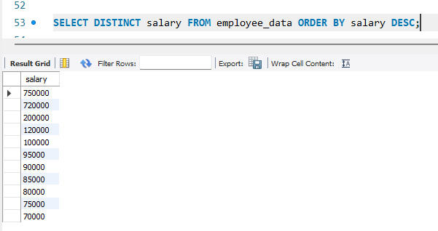
- How many distinct first name do we in our database?
21 unique f_names.
